**Vision Document for Trippal, A Dating App for Adventurers**

*Version 1.0 03 March 2022*

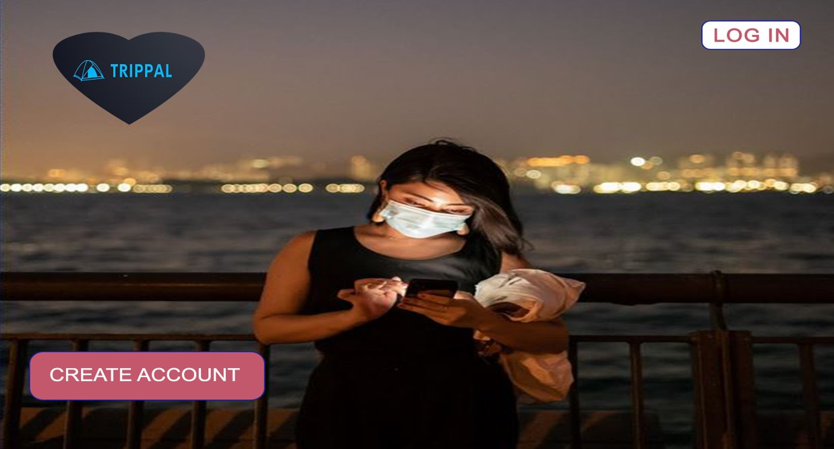

Table of Contents

1. Introduction.................................................................................................................1
   1. Product and Scope...................................................................................1
2. Problem Statement....................................................................................................1
3. Product Features.......................................................................................................3
4. Constraints................................................................................................................4
5. Risks.........................................................................................................................4
6. Stakeholder Descriptions..........................................................................................5
7. Project Team Members.............................................................................................6
8. **Introduction**
   1. Purpose and scope

This document outlines the vision for Trippal Dating Webapp. The purposes of this document are:

* Identify the problems and limitations within the dating applications that are currently available
* Describe additional features for the Web application
* Propose a solution
* Identify constraints to the proposed solution
* Identify the software development team and each person’s roles

1. **Problem Statement**

| The problem of | * Lack of improvement in matching algorithm as dating app market audience increased by 80% in the past six years * Dating app users are matches using irrelevant metrics and statistics * Current dating apps like Bumble, Tinder, and OkCupid have little to no options to recommend profiles based on a preferred outdoor activity * No dating app specifically for those seeking outdoor partners or adventurers |
| --- | --- |
| Affects | * Users of the app who want to meet like-minded adventurers |
| Causing an impact of | * Lack of compatibility between users * Fewer satisfactory dating experiences |
| A successful solution would provide | * An application that allows users to   + Create an account and dating profile through a web-based application     - Pictures can be uploaded through camera roll or from Facebook/Instagram   + Users complete profile questionnaire and include their preferred adventure   + The matching algorithm will consist of adventure preference as a key metric * Users can edit and delete profiles when needed * Users can match with potential mates who meet their preferences * Users can view and message matches |

1. **Product Features**
   1. **Ability to Allow Multiple Users to Create Profiles Simultaneously** 
      1. **Stores Shareable Profiles Information**

Users will be prompted to create a profile to ask for the following information:

* + - * Display Name
      * Date of birth to calculate age
      * Gender
      * Preferred Gender of Matches
      * At least two profile pictures
      * Questionnaire to gather information for profile
      * “About Me” and Interesting sections
      * Personal attributes, i.e., number of children, desire for having children, income, smoking and drinking tendencies, profession, education, drug or alcohol use, and disabilities
    1. **Profiles Can be edited or deleted**
    2. **Information for profile can be uploaded from Instagram or Facebook social media platforms**
  1. **Matching Algorithm to connect user**

Users will present the profiles of other users within the preferred radius. After reviewing the pictures and description, the user can dismiss the profile by swiping left or like the profiles by swiping right.Users will have the option to filter based on personal attributes of potential matches. Users can unmatch or block after matching

* + 1. **Direct Messaging and Video Chat Feature to Communicate with Matches**

After two users have liked each other profiles, the user will be matched and have the ability to direct message and video call each other. Users will be able to communicate with multiple matches in separate chats

* 1. **Exit Survey Upon Deletion of Profile**

When a user chooses to delete their profile, they are presented with a brief survey so the development team can learn their reason for leaving and obtain additional feedback on the application

1. **Constraints**
   1. Design Constraints

The system will be developed using the following tools and languages:

* + MongoDB
  + Express
  + Angular
  + Node.js

4.2. Browser Compatibility

The system will be web-based and assessable on all major web browsers

1. **Risks**

Below are a list of possible risks that may occur once the application is implemented

* + Interface is not user-friendly
  + Unclear or unmet goals for success criteria
  + Requirements need to be corrected or removed to meet multiple end-users’ needs

1. **Stakeholder Descriptions**

| Name | Represents | Role |
| --- | --- | --- |
| Jessica Muh | Project Manager | Manages the whole project and monitors team activity |
| Fremont Lowe, Makeen Majlis, Gracieux Mwisa, and Djemila McCray | Project Team | Performs development and testing of and for the application |
| Target demographic for dating apps for adventures | Customers | Target audience for the application; requirements are based on customer’s needs |
| Jim Turner | Marketing Team Lead | Creates and maintains a social media and email marketing campaign to attract new customers |
| Franklin Rose | Budgeting Team Lead | Determines budget for the project and reserves funding |

1. Project Team Members

| Name | Project Role | Responsibilities | Area Represented |
| --- | --- | --- | --- |
| Jessica Muh | Lead and Scrum Master | Designates roles to each member of the project team and supervises overall process | Planning and Software |
| Fremont Lowe | Back-end Development | Develop and maintain system | Software |
| Makeen Majlis | Project Management/ Documentation | Create user stories, and documents tasks | Planning |
| Gracieux Mwisa | Front-end Developer | Design application interface | Software |
| Djemila McCray | Product Owner and Project Management/ Documentation | Create vision document for end product | Planning |